Five Angle Rules-Answers
Key Stage 3: 2003 Paper 2 Level 3-5
1.
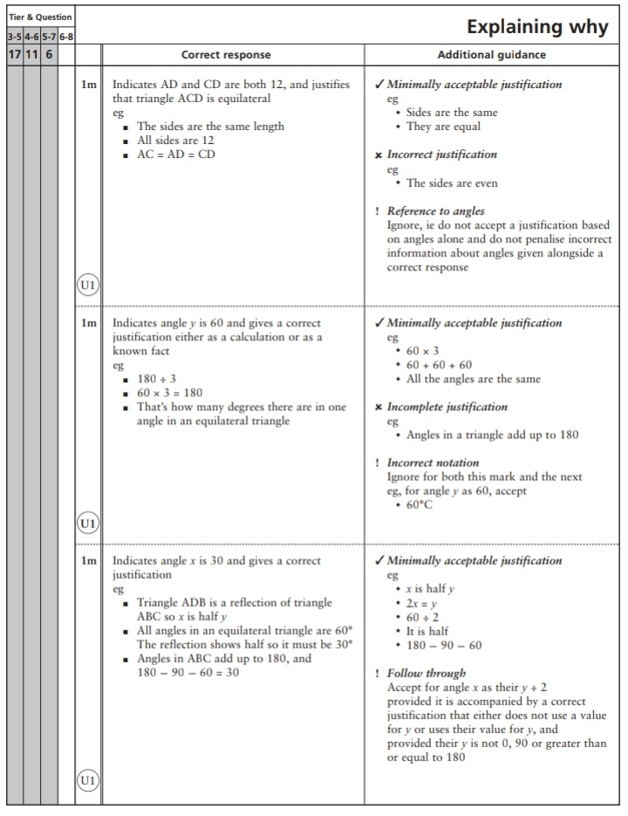
Key Stage 3: Paper 2 Level 4-6
2.
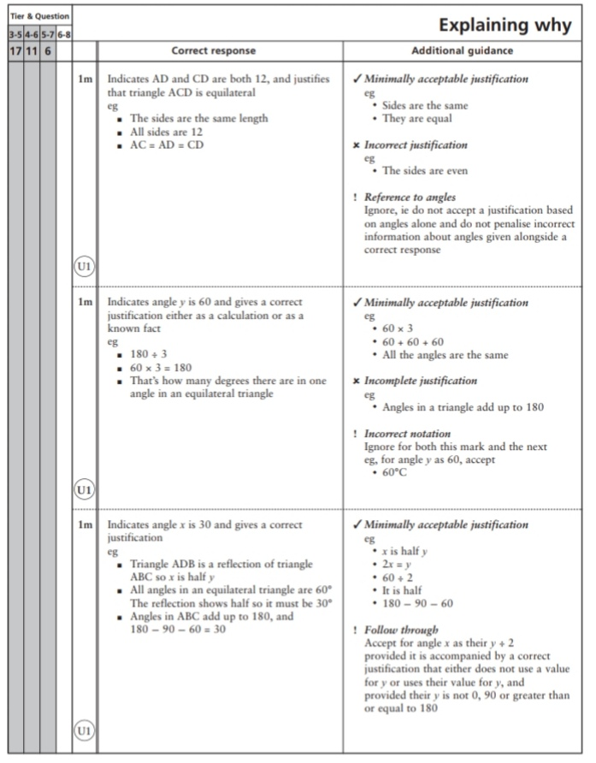
Key Stage 3: 2004 Paper 2 Level 3-5
3.
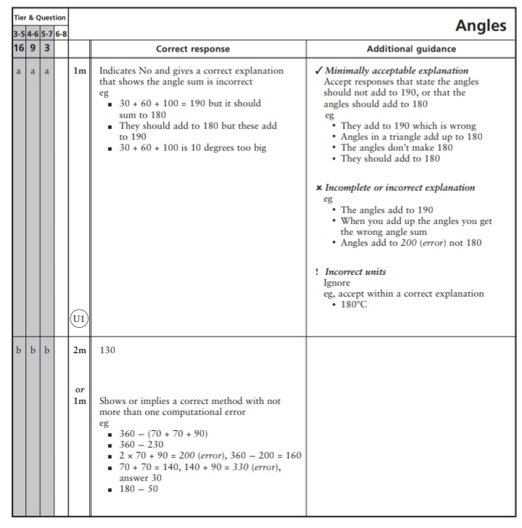
Key Stage 3: 2004 Paper 2 Level 4-6
4.
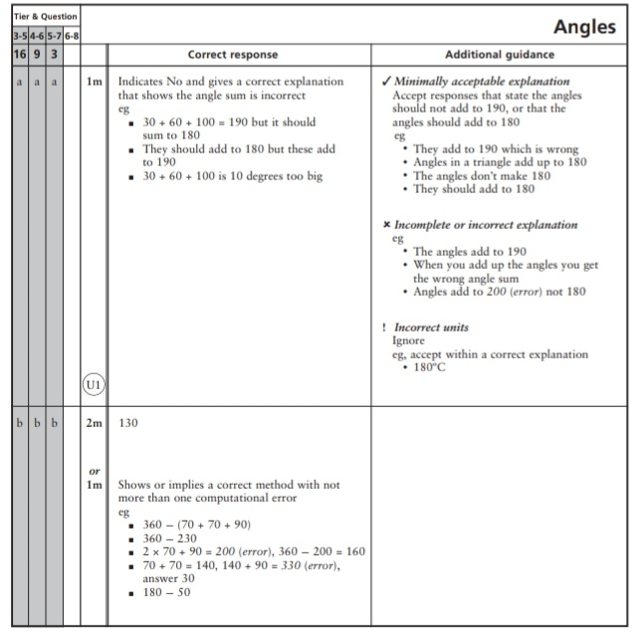
Key Stage 3: 2005 Paper 1 Level 3-5
5.
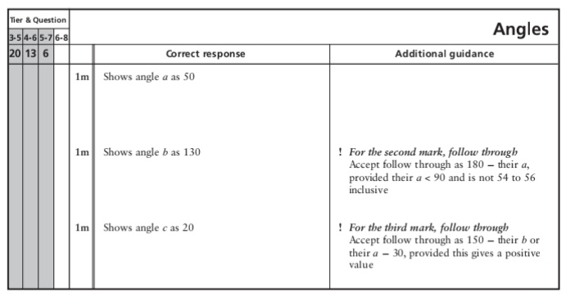
Key Stage 3: 2005 Paper 1 Level 4-6
6.
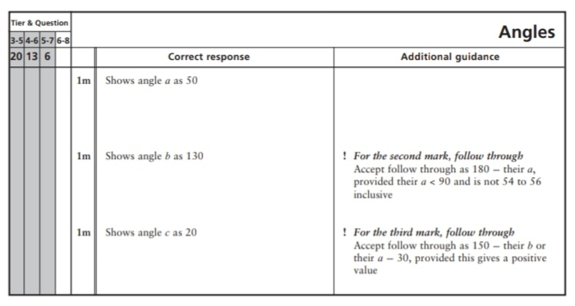
7.
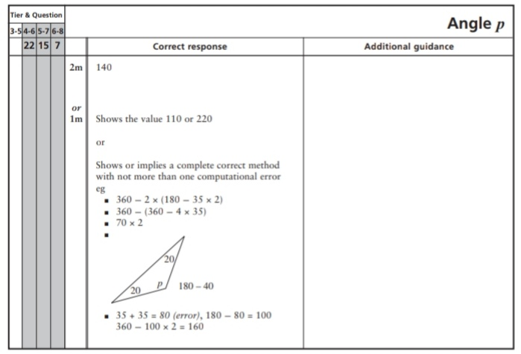
Key Stage 3: 2007 Paper 2 Level 3-5
8.
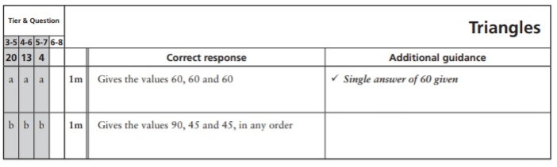
9.
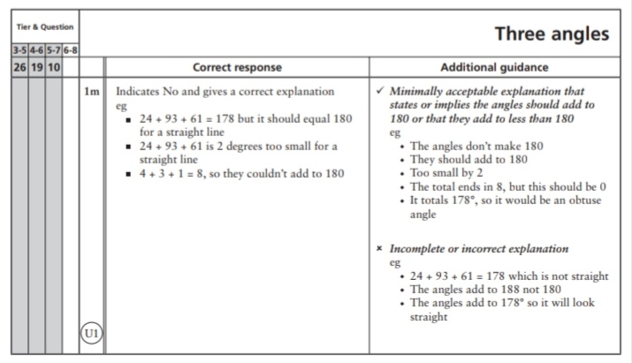
Key Stage 3: 2007 Paper 1 Level 4-6
10.
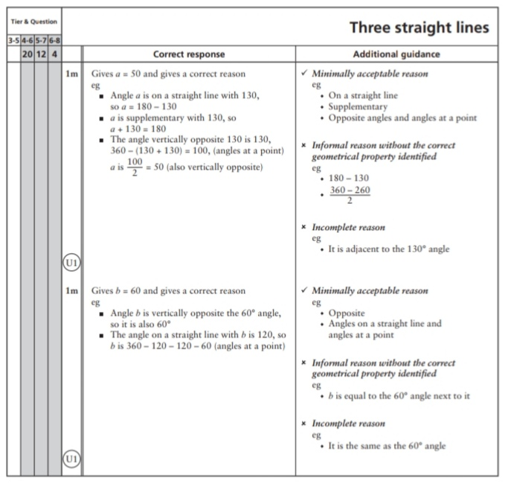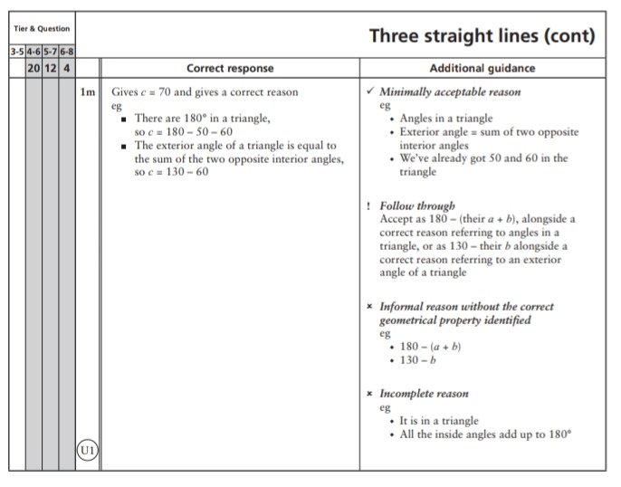
Key Stage 3: 2007 Paper 2 Level 4-6
11.
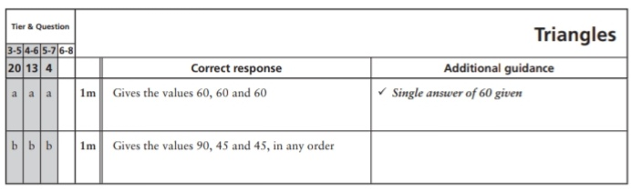
12.
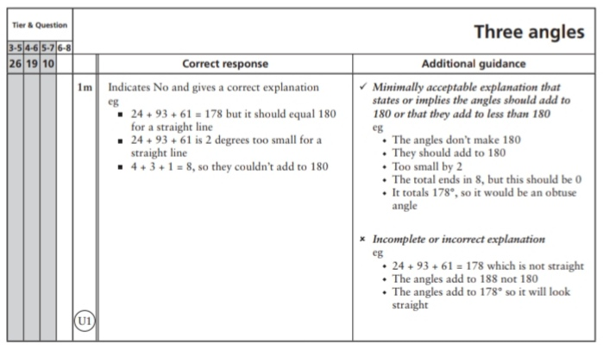
Key Stage 3: 2008 Paper 2 Level 4-6
13.
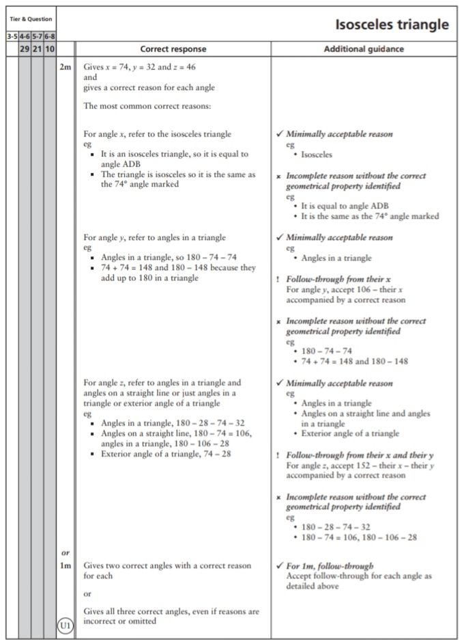
Key Stage 3: 2009 Paper 1 Level 3-5
14.
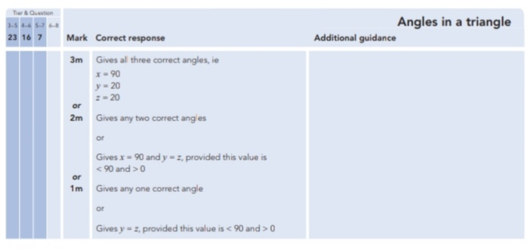
Key Stage 3: 2009 Paper 1 Level 4-6
15.
Key Stage 3: 2009 Paper 2 Level 4-6
16.
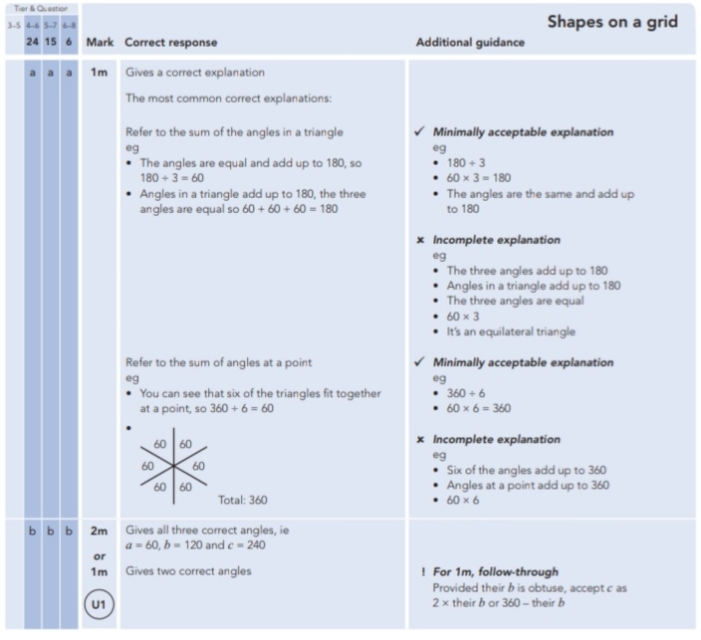
Key Stage 3: 2010 Paper 1 Level 4-6
17.
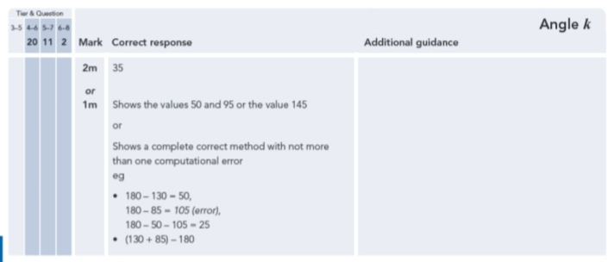
Key Stage 3: 2010 Paper 2 Level 4-6
18.
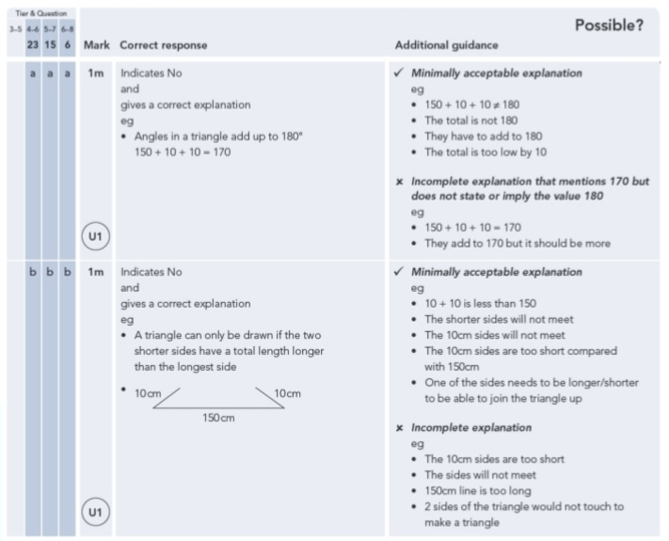
Key Stage 3: 2011 Paper 1 Level 4-6
19.
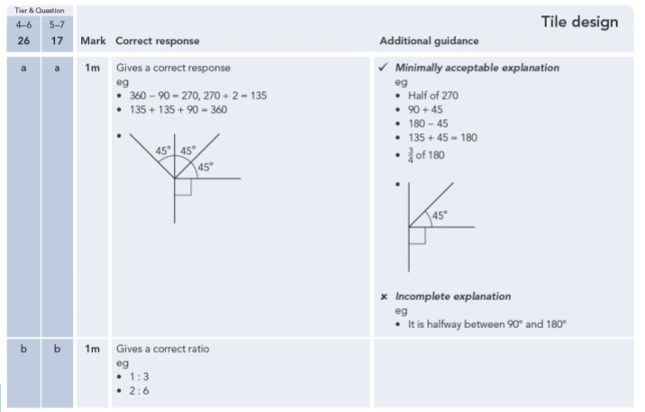
Key Stage 3: 2011 Paper 2 Level 4-6
20.
